Uncertainty in Measurements
The comparison always involves some uncertainty. If the tape measure has marks every foot, and the table falls between the sixth and seventh marks, you can be certain that the table is longer than six feet and less than seven feet. To get a better idea of how long the table actually is, though, you will have to read between the scale division marks. This is done by estimating the measurement to the nearest one tenth of the space between scale divisions.
- Which of the following best describes the length of the beetle's body?
a. Between 0 – 2 inches c. Between 1.5 and 1.6 inches
b. Between 1 – 2 inches d. Between 1.54 and 1.56 inches
c. Between 1.546 – 1.547 inches
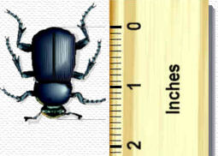

- Give the correct length measurement for the steel pellet for each of the rulers, as a single number rather than a range:

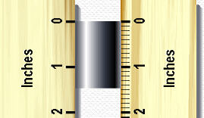
Left Ruler_________ Right Ruler ___________

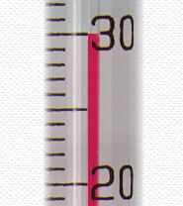
A zero will occur in the last place of a measurement if the measured value fell exactly on a scale division. For example, the temperature on the thermometer just should be recorded as 30.0°C. Reporting the temperature as 30°C would imply that the measurement had been taken on a thermometer with scale marks 10°C apart!

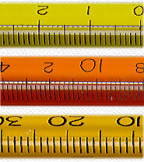
- A temperature of 17.00°C was recorded with one of the three thermometers to the left. Which one was it?
- Top
- Middle
- Bottom
- Top & Middle
- Middle & Bottom
- All

Use the bottom of the meniscus (the curved interface between air and liquid) as a point of reference in making measurements of volume in a graduated cylinder, pipet, or buret. In reading any scale, your line of sight should be perpendicular to the scale to avoid 'parallax' reading errors.
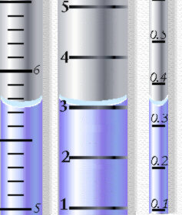
- The graduated cylinder on the left has scale marks 0.1 mL apart, so it can be read to the nearest 0.01 mL. Reading across the bottom of the meniscus, a reading of 5.72 mL is reasonable (5.73 mL or 5.71 mL are acceptable, too). Enter the volume readings for the middle and right cylinders below, assuming each scale is in mL.

Middle_________mL
Right __________mL
- A sample of liquid has a measured volume of 23.01 mL. Assume that the measurement was recorded properly.
- How many significant digits does the measurement have? _______________
- Suppose the volume measurement was made with a graduated cylinder. How far apart were the scale divisions on the cylinder, in mL?
10 mL 1 mL 0.1 mL 0.01 mL not enough information
- Which of the digits in the measurement is uncertain?
"2" "3" "0" "1" not enough information
- ROUNDING:
  - 0.43479 rounded to 3 figures is ________________________
  - 1.756243 rounded to 4 figures is ________________________
  - 9.973451 rounded to 4 figures is ________________________
- ALL TOGETHER:
  - How many significant figures are in 1,500?
  - How many significant figures are in 1,500.01?
  - How many decimal places are in 2.234?
  - Which number is less accurate: 301 or 3.01?
  - What is 60 + 83.2, using significant figures?
  - What is 0.158 + 0.4, using significant figures?
  - What is 0.11 – 2.2, using significant figures?
  - What is 63.4 × 151, using significant figures?
  - What is 610 ÷ 9.1, using significant figures?
  - Give a number between –1 and 1 that has 5 significant figures.
  - Give a number greater than 1,000 that has 2 decimal places.
  - Give a number that is 4 digits but only has 3 significant figures.

